Bio Peggy Smith

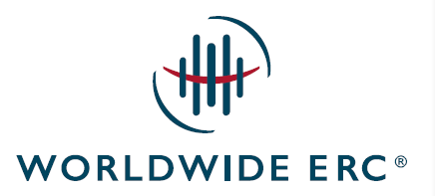

Peggy Smith, SCRP, SGMS-T

President and Chief Executive Officer
Worldwide ERC®

Peggy Smith, Worldwide ERC® President and Chief Executive Officer, is an experienced and innovative business leader and accomplished global strategist. She is skilled at maximizing the association’s current opportunities, after experiencing a stellar career at Microsoft, where she expanded their workforce mobility reach from U.S. to global coverage.

She is recognized in business circles as a purposeful world citizen and a highly effective business development leader who builds strong relationships with a range of professionals in workforce mobility, talent management, staffing, benefits, payroll, finance, and procurement.

She served on a number of Worldwide ERC® committees and task forces, and on its Board of Directors and Executive Committee prior to her CEO position, and is equally familiar with global and U.S. member issues. She brings a deep understanding of each member segment’s needs and perspectives and an unwavering focus on the advancement of the workforce mobility industry and Worldwide ERC®. She has turned a practiced eye on expanding the association’s footprint in the APAC and EMEA regions, and under her leadership, the organization made significant inroads in the LATAM area in 2015, and is expanding programs in the region for mobility professionals.

Peggy holds a BA in marketing from Seattle University, as well as both Worldwide ERC® designations: the Senior Certified Relocation Professional/SCRP® and the Senior Global Mobility Specialist/SGMS®-T (including the talent mobility certification). A frequent presenter at mobility and HR-related conferences around the world, Peggy has also guest-lectured on talent mobility at Georgetown University and Seattle University.

Peggy can be reached at:
Worldwide ERC®
4401 Wilson Blvd., Suite 510
Arlington, VA 22203
+1 703 842 3407
psmith@WorldwideERC.org
www.WorldwideERC.org

